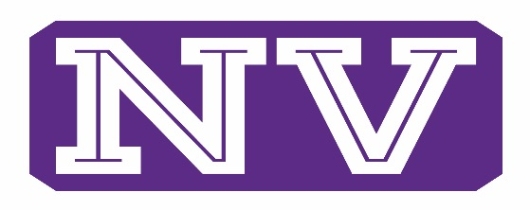

ATHLETICS
Social Media Guidelines for Coaches and Athletes

- Assume nothing is private, ever. If you are putting your thoughts or any pictures on the internet, there is no “invasion of policy.”

- Remember that your audience is vast, and unknowable. You have no idea who will ever see what you write or post on the internet. Anyone from your best friend on the team, to your head coach, to your biggest rival, to your teachers can see what you post. Keep in mind that this can be seen by the world. Your microphone to the world is right at your fingertips. Be wise. This applies to coaches as well.

- It is against WIAA rules to engage and influence any non- NVSD student for the purpose of enrolling at NVSD for athletics. Do not use social media for this purpose. Refer anyone asking about our Athletic teams or department to the Athletic Director of Director of Admissions.

- Do not discuss injuries, either yours, or that of any of your teammates.

- Never post pictures from the locker room, practice or game without the permission of the Athletic Director or Head Coach.

- Complaining about your coaches or teammates will not solve anything. Talk to them directly to solve problems to make yourself and your team better. Coaches are included here as well. Use a positive approach to conflict management.

- Do not talk about your opponents in a negative fashion. Stay away from trash talking your past, present or future opponents.

- Your tweets and post can be permanent. They are a permanent record. You can’t take back what you put out on the internet for everyone to see.

- If you retweet something, you agree with it and promote it. Keep this in mind.

- Play with your athletic skills, not your mouth and your fingers on the keyboard.

- Coaches should contact Athletes only in group settings. 1-1 texts and e-mails can be lead to problems. Also keep content about your sport, practices times, games, and any adjustments to these topics. Any personal conversations between athletes and coaches via social media are highly discouraged, and are not condoned in any manner.
Coaches and Student-athletes who violate the Athletic Department Social Media Policy may result in disciplinary action – including temporary or permanent suspension from the team – as determined by the NVSD Administration.

