Shelton HS WCD 3A 3rd Place State Qualifier
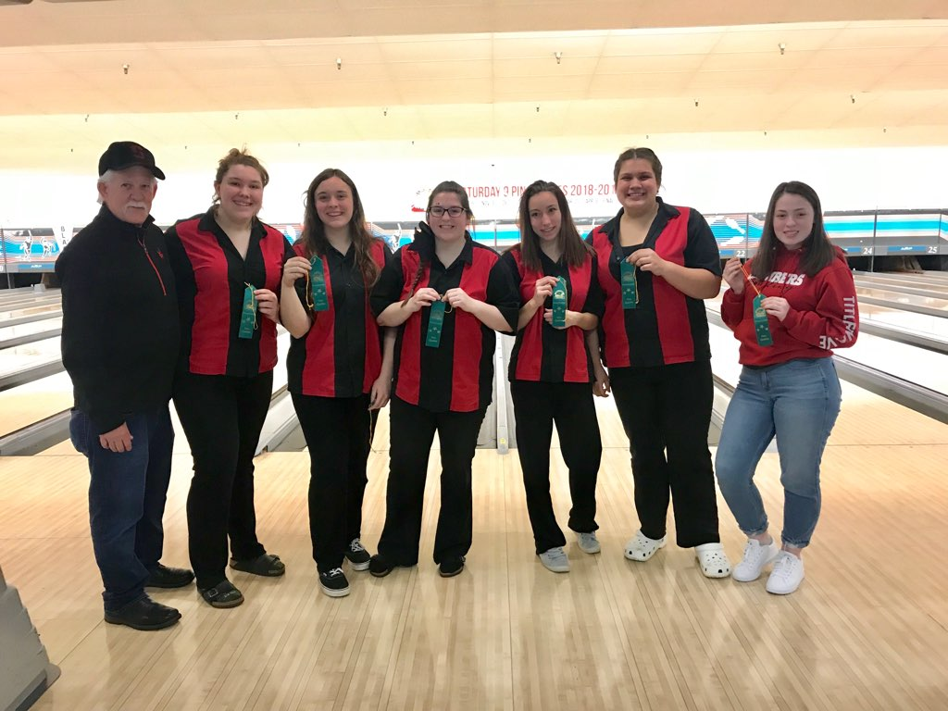

Bethel HS WCD 3A 4th Place State Qualifier

