Puyallup HS 2019 WCD-SWD 4A Bowling Champions
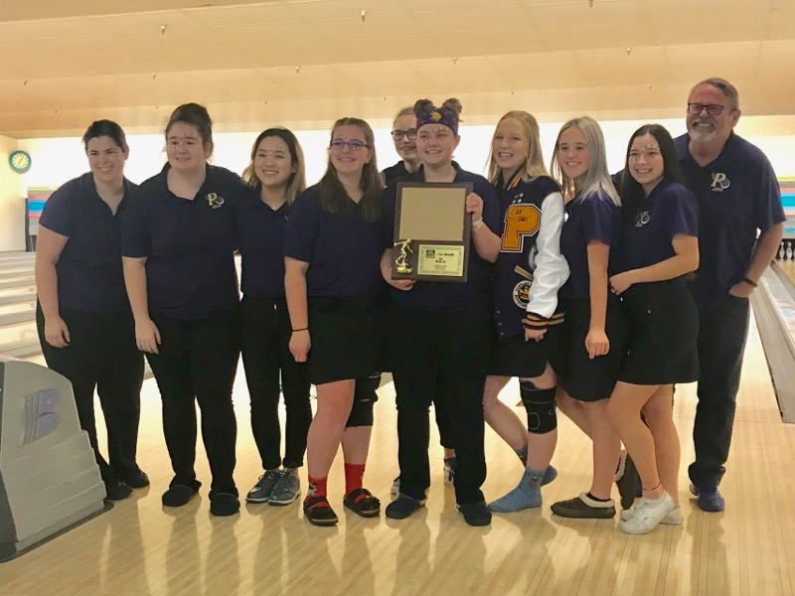

Thomas Jefferson HS 2019 WCD-SWD 4A 2nd Place