Franklin Pierce HS 1A/2A WCD Tri-District 3rd Place-State Qualifier
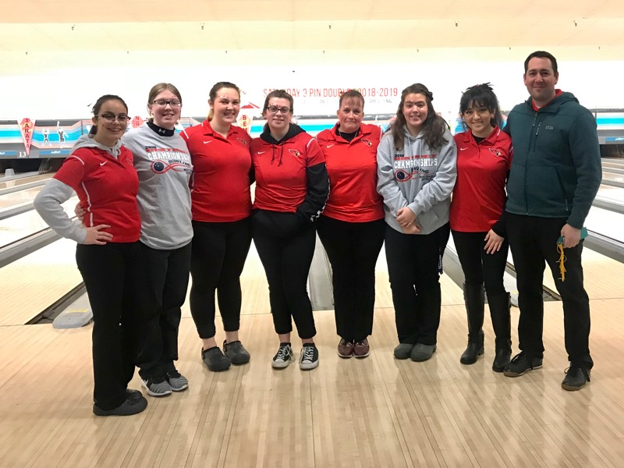

Klahowya HS 1A/2A WCD Tri-District 4th Place-State Qualifier
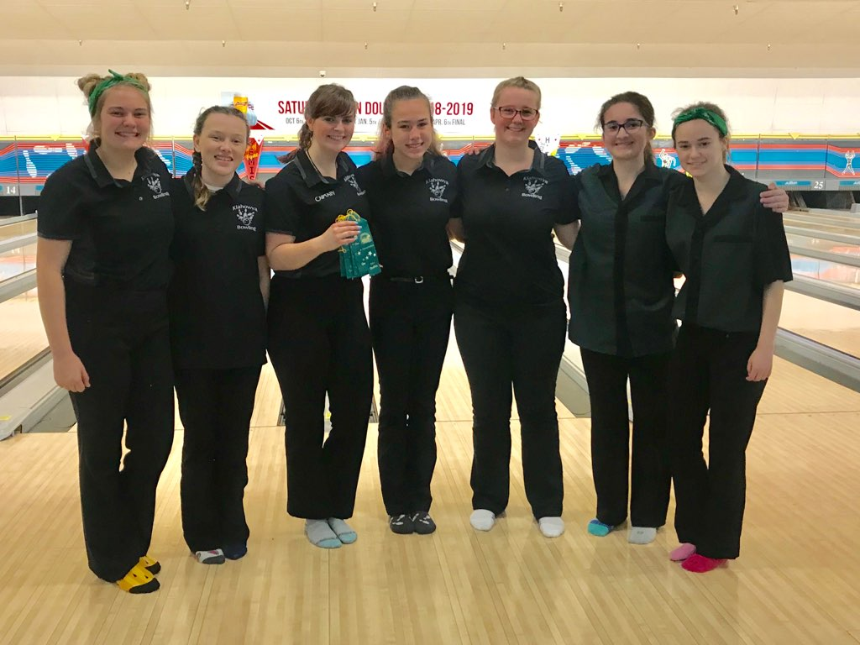

Steilacoom HS 1A/2A WCD Tri-District 5th Place-State Qualifier

